**Guide for installing JDK (Java Platform), Eclipse (Java Code Editor), and Git Client.**

**Note-** This guide is for Windows. For macOS users, perform the equivalent steps.

**JDK 8 (Java Platform) Installation.**

1. Check if you have Java 8 (64 bits) or Java 11 (64 bits) already installed on your computer.

1. Open a Windows command prompt or a Mac terminal and type “java –version.” If you get the “java is not recognized” message, it means that you need to install java, so jump over to step 2.

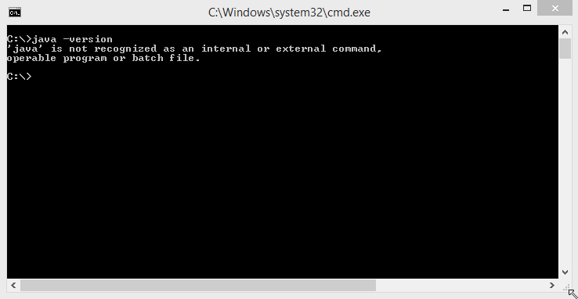

1. If you get a message like in the picture below, it means that you have Java JRE installed, but we still need to verify that you have Java JDK. Also, if it doesn’t show it’s a 64 bits version, it means it’s a 32 bits version and must be uninstalled and replaced by a 64 bits version.

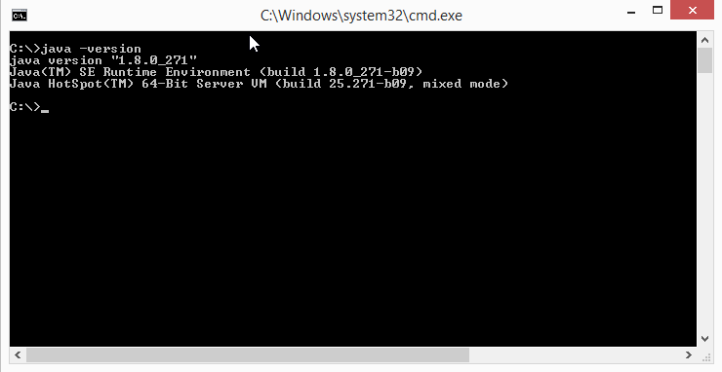

1. In Windows, go to “Control Panel,” then go to “Programs” and check if “Java SE Development Kit (64 bits)” is listed in the installed program's panel. First, you need to ensure you have a 64 bits version installed. If listed, but it doesn’t show it is a 64 bits version, that means it is 32 bits, and you must uninstall it and install a 64-bit version. Once you have JDK 8 installed, you can jump to the Eclipse Installation. For macOS users, perform the equivalent process for your operating system.

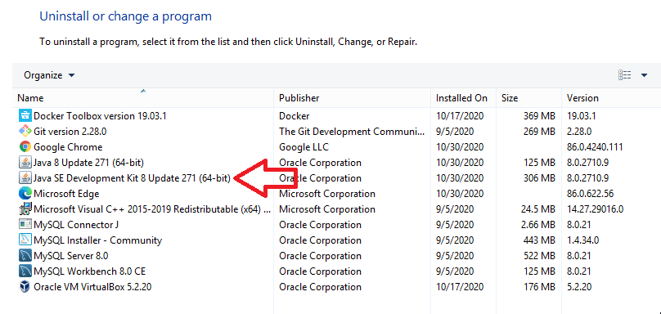

1. Download JDK 8 from the Oracle Web Site. JDK 8 is enough for our course purposes.
2. Open to the following URL:

<https://www.oracle.com/technetwork/java/javase/downloads/jdk8-downloads-2133151.html>

You will get the following web page (pick the appropriate 64-bits java installer for your system)

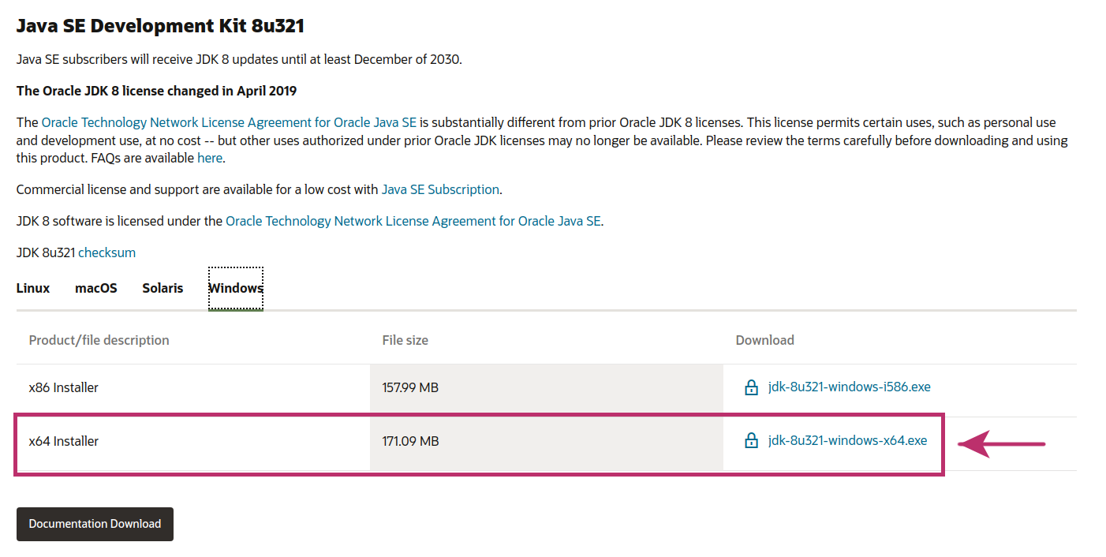

1. Accept the license agreement and hit the gray button.

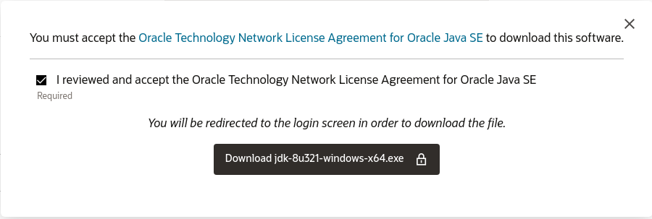

1. Create an Oracle Account (it’s free) or provide your credentials if you already have one. After completing this step, your download will start.

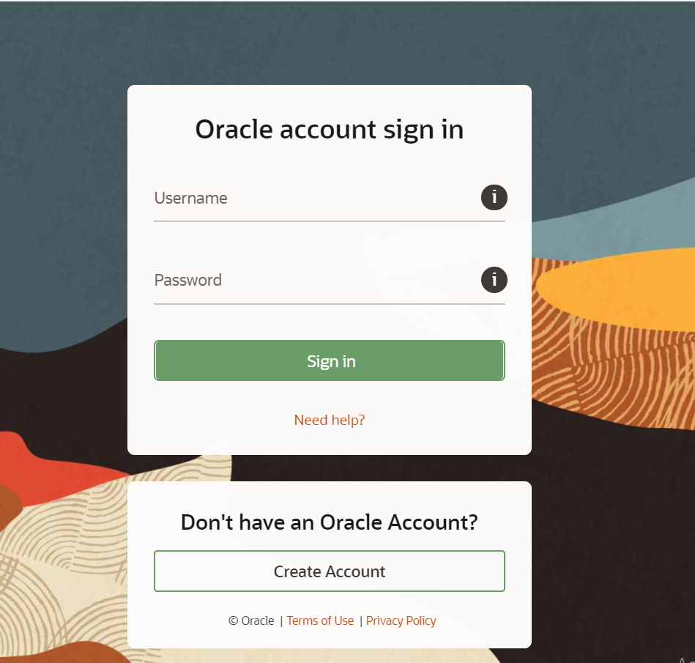

1. Install JDK 8 (64 bits) on your computer.
2. Execute the installer downloaded in the previous step. Always accept the default settings unless you need something specific for your system.

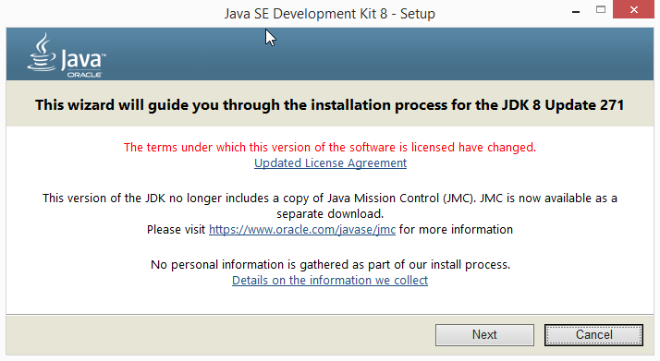

1. Hit the Next button.

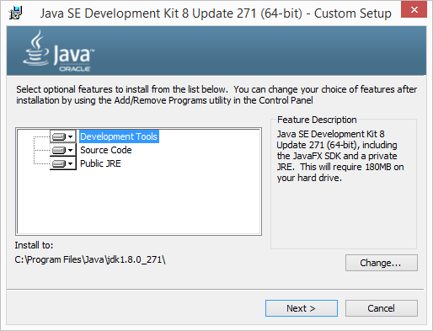

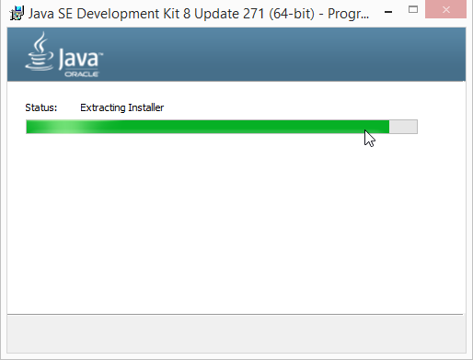

1. Hit the Next button.

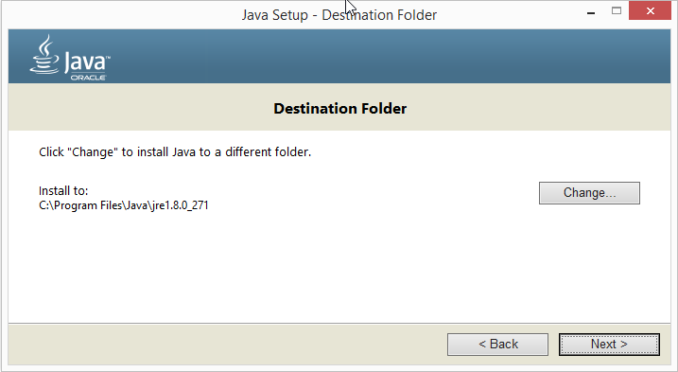

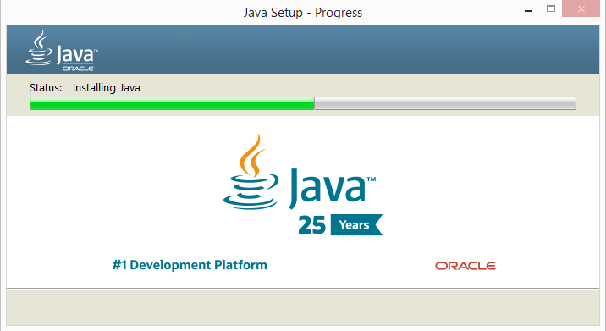

1. At the end of the installation, you will get a confirmation window that says it was successful.

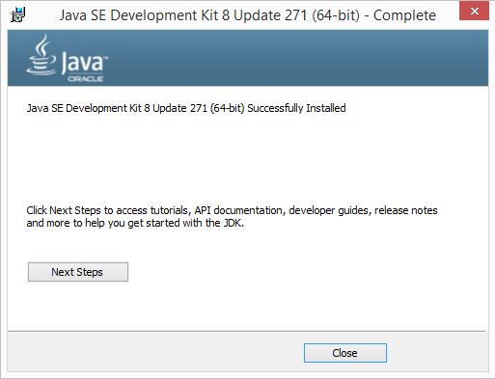

1. Open a new Windows command prompt or a Mac terminal to verify Java was installed correctly.



**Eclipse IDE (Java Code Editor) Installation.**

**Note-** For Eclipse, there is no installation. Instead, we need to download a zip file, unzip it in an appropriate directory on our computers, and we are ready to go. IDE stands for Integrated Development Environment.

1. Go to the Eclipse Website using the following URL:

<https://www.eclipse.org/downloads/packages/release/2020-03/r>

You will find many eclipse flavours. Download “Eclipse IDE for Enterprise Java Developers” for your operating system. Do not download “Eclipse IDE for Java Developer” because this IDE doesn’t have all the features we need for the course.

See the next page.

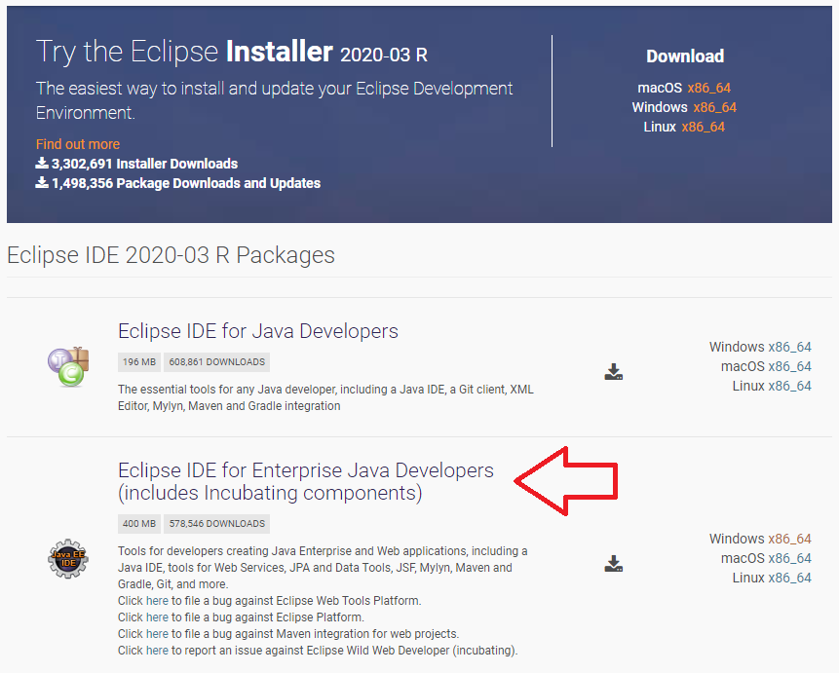

1. Once the file download is completed, unzip it in an appropriate folder (a folder you have permission to write in it).
2. Navigate into the folder structure created in the previous step, and you will find a file named “eclipse.exe.” Execute that file, and you will get a popup window that asks you to provide a workspace name. The workspace is just a folder in your file system where eclipse projects are stored. You can use the default workspace suggested by Eclipse, but we recommend providing your workspace name. In the picture below, the workspace is in Drive D, but you can choose your convenience folder.

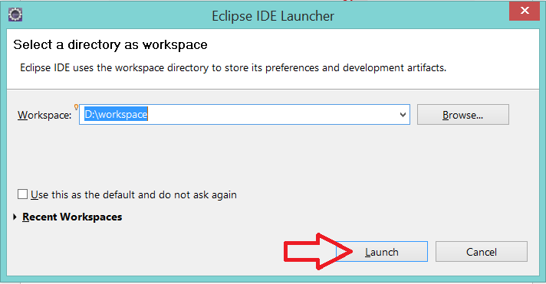

1. You will see the Eclipse IDE’s GUI. Finally, complete the steps detailed in the “*2 - BusyQA - Eclipse Setup*” document to set up the JDK (Java Platform) in Eclipse IDE.

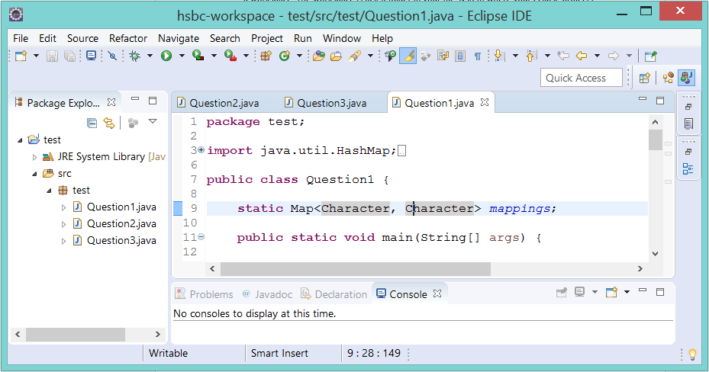

**Git Client Installation (Only for Windows Systems)**

**Note–** Git is a distributed version control system for tracking changes in the source code during software development. We use Git Client to interact with GitHub. This Client installation is only needed in Windows systems as Mac comes with Git Client out of the box.

1. Go to Git Website using the following URL:

<https://git-scm.com/downloads>

You will get the following web page (pick the windows installer)

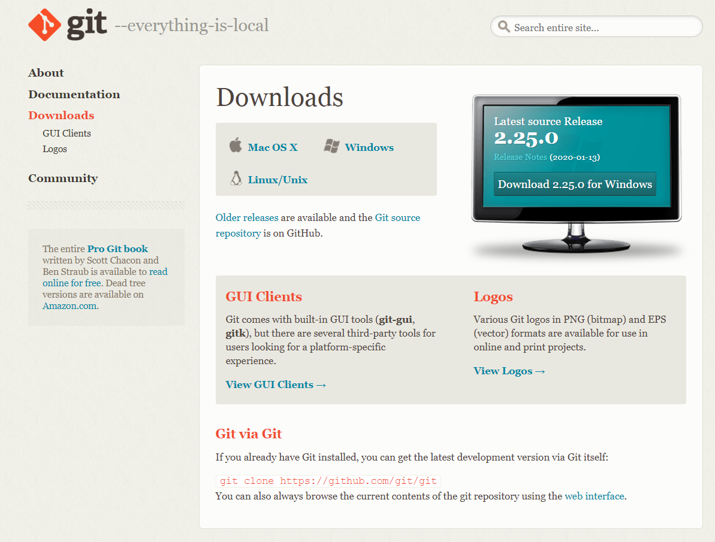

1. Install Git Client on your computer.
2. Execute the installer downloaded in the previous step. Always accept the settings by default unless you need something specific for your system.

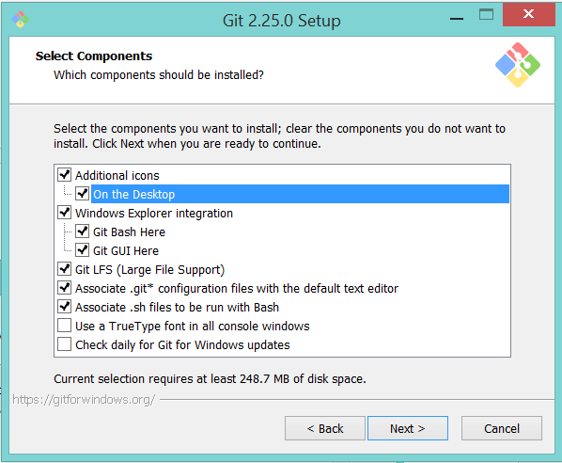

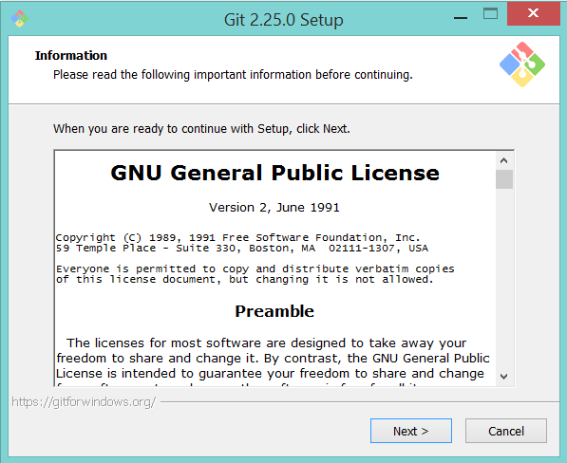

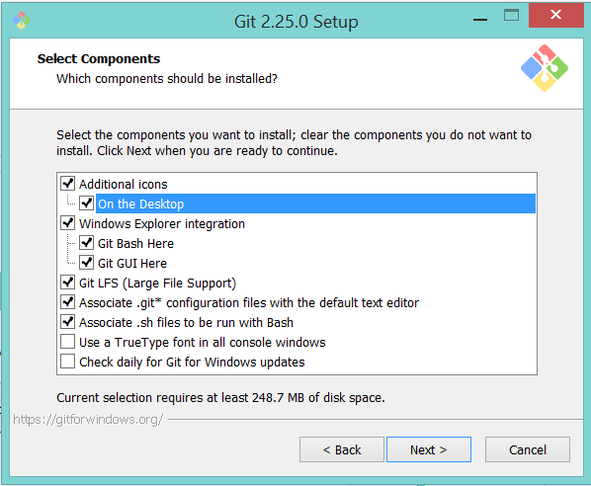

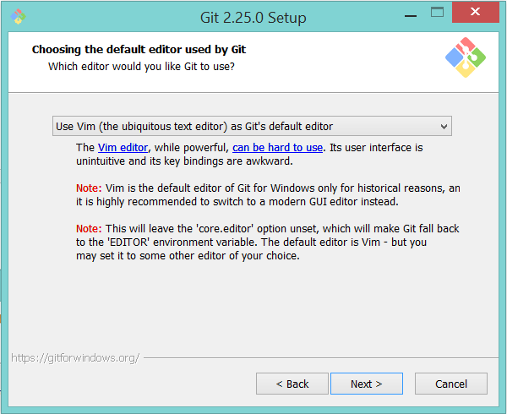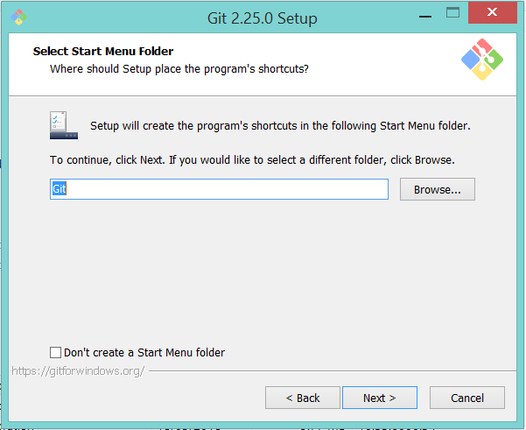

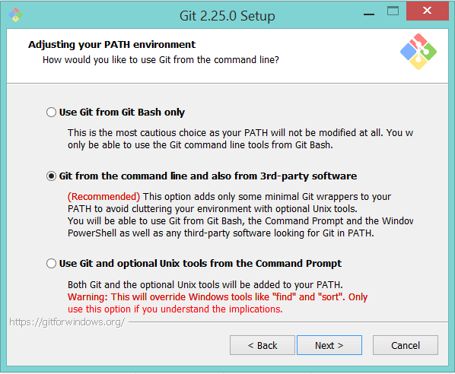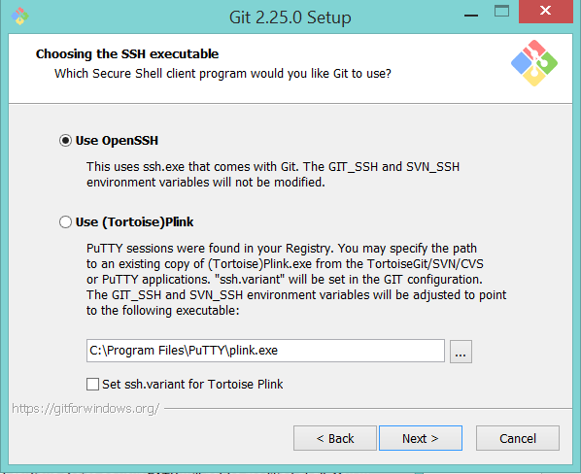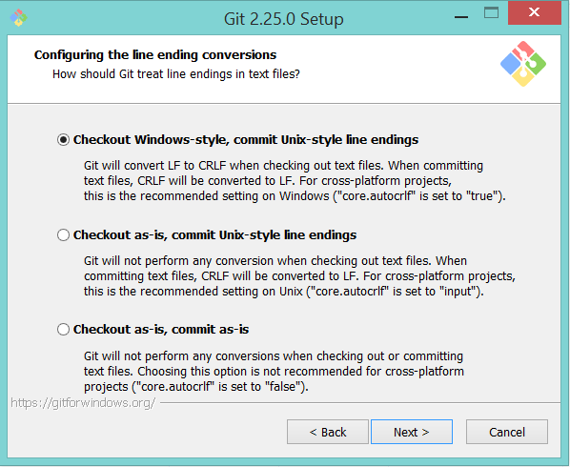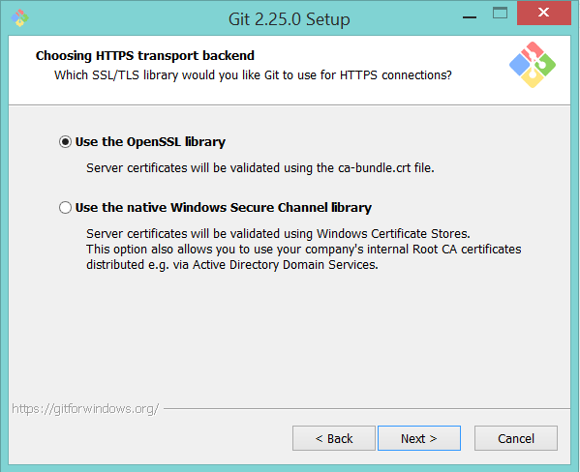

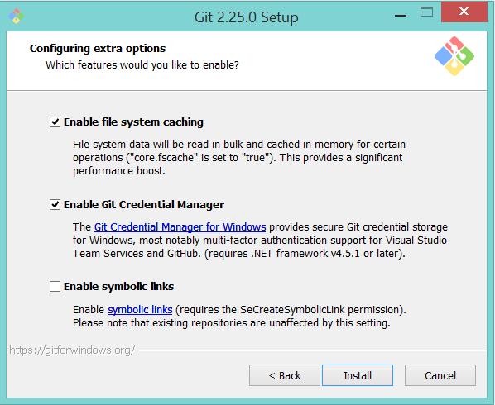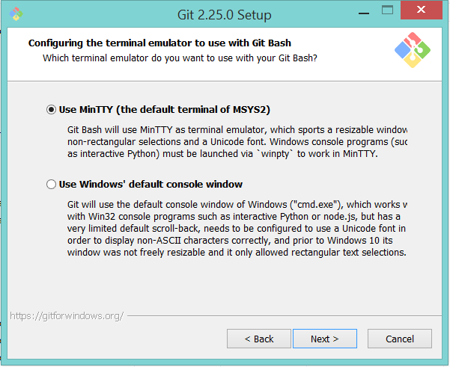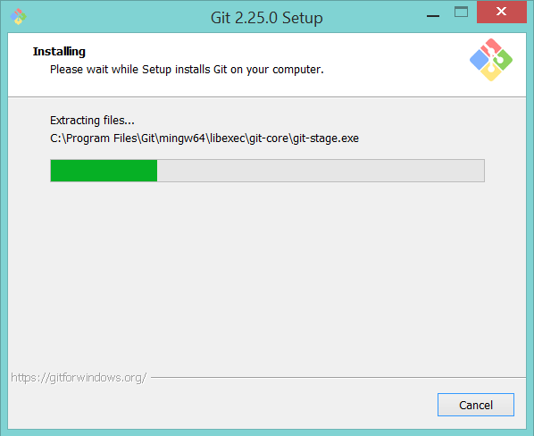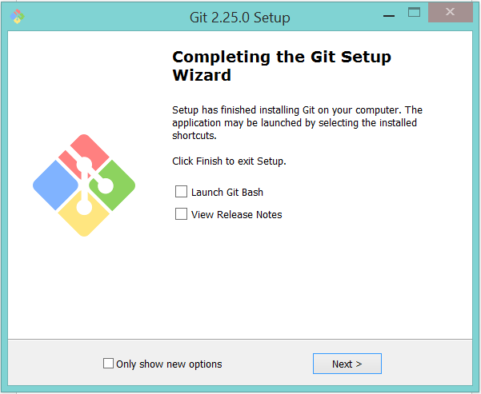

1. Once the installation is completed, do the following:

Run “Git Bash” from the Git Bash icon on the desktop or go to Start/Programs/Git and run “Git Bash” from there.

The following window will pop up, and you will be all set.

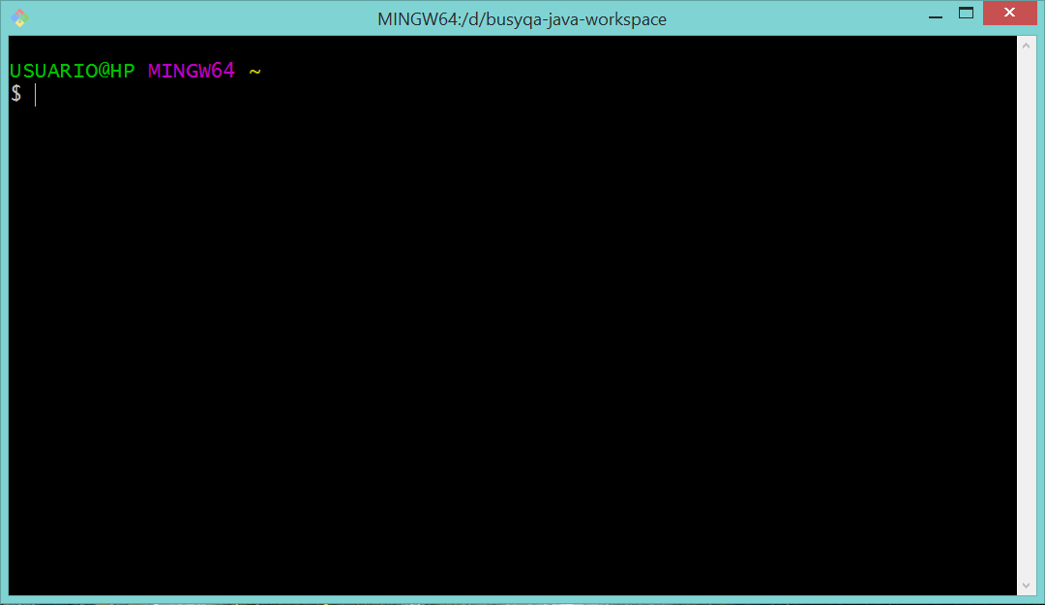

//End